The John F. Kennedy Assassination FAQ
By Jedediah Laub-Klein & Joseph E. Green (2010)
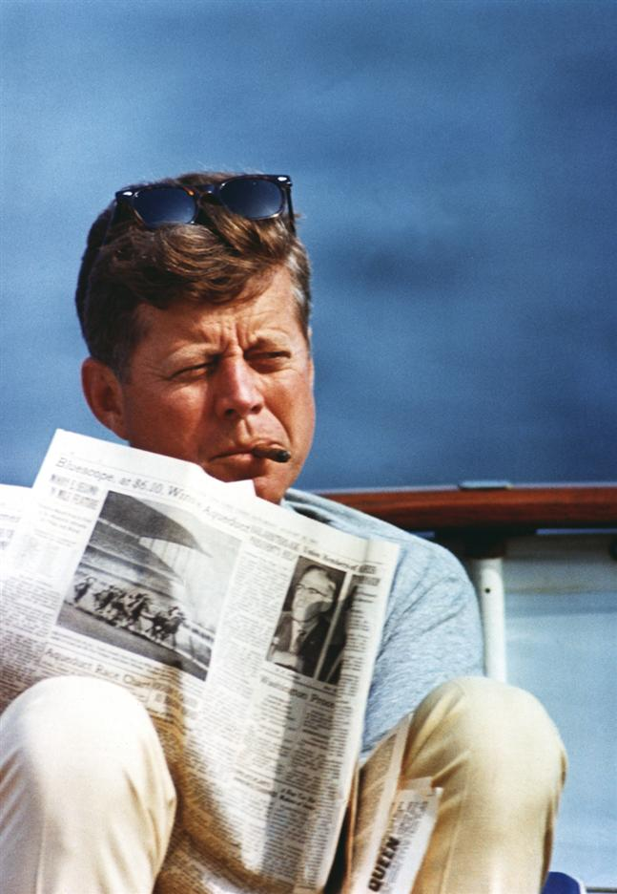

- What are the basics of the case?
- Why suspect Lee Harvey Oswald?
- Who was Jack Ruby?
- What was the composition of the Warren Commission?
- What is the single bullet or “magic” bullet theory?
- What is the “Mexico City episode”?
- What happened to Kennedy’s brain?
- Who could have done this?
- Did the Mob/the Federal Reserve/French Corsicans kill JFK?
- Who benefits from a crime like this?
- If this were really a conspiracy, wouldn’t someone have come forward by now?
- Wouldn’t there need to be hundreds of people involved if it really were a conspiracy?
- Why would the establishment kill JFK, when he is a member of that same establishment?
- Why do you still care about the case?
- What is the historical context of the JFK assassination?

Opening Remarks:
This was written to be the entry level into the world of JFK assassination conspiracies.
If you are new to this subject, these are some of the basic problems that the conspiracy community has with the assassination of John Fitzgerald Kennedy. These may convince you there was a conspiracy or not. They hopefully will pique your interest and cause you to begin to seek out more information. The choice is yours.
If you are a long-time researcher you can use this to spread the information to your friends who aren’t aware of these issues, either using the whole article or just a few questions.
The questions are ordered so that the conspiracy argument should build. We start with basic questions about who the players are and slowly build to much larger issues of the conspiracy itself.
Please remember, as you read this, that conspiracy simply means two or more people committing a crime. Despite how the term is often used, we are not here to discuss aliens, Bigfoot, or 2012. That is a different article. For some reason people like to put us all in one category. We aren’t in one category.
Also understand that the conspiracy community is a varied group. Some of us are reliable. Some are not. There are going to be internal arguments within any community. The same goes for this one. We do not speak for the community. This is simply Joe Green’s and Jedediah Laub-Klein’s views on these issues and even between the two of us there are minor differences. What follows is what we do agree on and is by no means all the information available. It is merely a peek into some of the issues. The solution is yours to find.
Good luck, happy hunting, and we hope you enjoy the piece.
- What are the basics of the case?
What follows are facts about which no one will disagree. John Kennedy needed to do a re-election campaign stop in Texas, a state he had barely won in 1960. He was coming to town to woo votes, show off his wife, and give a speech at a local trade mart.
He arrived in Dallas on Friday, November 22, 1963, at 11:45 AM and began a drive through downtown to the trade mart. There were four people in the back of the Lincoln Continental convertible sedan: President John Kennedy, Texas Governor John Conally and their wives. As his motorcade drove through Dealey Plaza, shots were fired. Both Conally and Kennedy were hit by gunfire and rushed to Parkland hospital.
Between 1:10 and 1:15 Officer J.D. Tippet is killed at Tenth and Patton.
- 1:50 pm Lee Harvey Oswald is arrested inside the Texas Theater after a short scuffle in which Oswald screams out “I am not resisting arrest.”
- 2:38 pm EST Walter Cronkite makes the following announcement: “From Dallas, Texas, the flash, apparently official: President Kennedy died at 1:00 PM Central Standard Time, 2:00 Eastern Standard Time, some—thirty-eight minutes ago.” His voice cracks but he continues on… “Vice President Johnson has left the hospital in Dallas, but we do not know to where he has proceeded. Presumably, he will be taking the oath of office shortly and become the thirty-sixth President of the United States.”
- 2:38 pm CST Lyndon Baines Johnson is sworn in as the thirty-sixth president of the United States.
- 7:05 pm Lee Harvey Oswald is charged with the murder of Officer Tippet.
- 11:36 pm Lee Harvey Oswald is charged with the murder of President Kennedy.
On Sunday, November 24, 1963, at 11:21 am, Lee Harvey Oswald is shot to death on live television by Jack Ruby.
Friday November 29, 1963: President Lyndon Johnson establishes the Warren Commission to look into the President’s murder. It is headed by Supreme Court Chief Justice Earl Warren and includes Allen Dulles, the former CIA director who was fired by Kennedy.
November 1964: The Warren Commission concludes that Lee Harvey Oswald fired all three shots that killed Kennedy and that there were no other conspirators.
November 23, 1964: All of the Warren Commission’s records are transferred to the National Archives. Some are sealed for 75 years. This is done "to serve as protection for innocent persons who could otherwise be damaged because of their relationship with participants in the case.”
September 30, 1998: The Assassination Records Review Board submits its findings to the President of the United States. These findings include new information about the autopsy of Kennedy and Oswald’s trip to Mexico, as well as a new look into the files of many people including Jim Garrison and Gerald Posner. These provide many new leads and a fresh look at older leads. This information is made public but few took notice. All future work should begin from these findings.
- Why suspect Lee Harvey Oswald?
The mere fact of Oswald’s arrest made him suspect, at least in the public’s mind, furthermore his life had many unusual aspects. When the Dallas police went through his belongings, they found two pieces of ID; both had his picture, but with different names: Alex Hidell and Lee Harvey Oswald. When asked which of these he was he responded, “You’re the policeman – you figure it out.”
He might as well have been speaking to all us. Oswald’s life is filled with oddities, to say the least.
Other reasons for suspicion are his travel history, his friends, and his actions. Oswald’s movements seem to be beyond his monetary means. He purchased a $1500 plane ticket to Moscow despite having only $208 in his account. He also seemed to have traveled on days when there were no flights. One example is his trip to Helsinki airport on a day when the only flights were military. Also suspicious is his speedy return from Russia. Over a twenty-month time period, Oswald makes inquiries about defection (but does not actually defect), marries a Russian woman and has a daughter. When he’s ready to return home, the he is granted permission to return to the United States within 24 hours! No one from the State Department ever meets him or interviews him. This suggests government contacts.
His friends are even stranger than his movements. Oswald was a declared Marxist-Leninist…yet his friends were all on the other end of the political spectrum. Among them is Clay Shaw an extreme right-wing activist whose companies were banished from Italy under suspicion of providing cover for fascist organization. He also worked with the CIA and had connections to Allen Dulles. Another friend was David Ferrie, a rabid anti-Communist who personally met former Cuban leader Fulgencio Batista on the latter’s arrival from Cuba after Castro’s victory. Ferrie had been heard plotting to kill Kennedy. A third friend was Guy Banister, an ex-FBI agent, who was using double agents to infiltrate student groups on New Orleans college campuses. When Oswald was seen handing out Communist leaflets by Banister’s secretary, Banister laughed and said, “He’s with us.”
Oddest of all was that Oswald flaunted his aberrant politics in the inhospitable south in the early ‘60’s. Oswald obtained literature and opened a branch of Fair Play for Cuba Committee in New Orleans. The only problem: he was the only member. This created a direct connection between him and a left-wing organization in a deeply conservative city like New Orleans, making him appear to be a Communist.
Another incident drew even more attention. Oswald asked a local anti-Castro Cuban militant named Carlos Bringuier whether he could make use of Oswald (an ex-Marine) in training Cuban exiles. Three days later Oswald was handing out pro-Castro literature when Mr. Bringuier and a group of friends found him at the corner and started a fight with him, which a tourist caught on film. The police arrived charging everyone with disturbing the peace. At the police station, Oswald asked to see an FBI agent (not exactly the norm). Also, a Lieutenant Francis Martello said of the incident, “He seemed to have set them up to create an incident.” In other words, this was staged. The event got Oswald a number of things including a radio interview with anti-Communist Ed Butler. When Butler ambushed Oswald about his attempted defection to Russia he responded, “I was under the protection of the…uh…that is to say, I was not under the protection of the American government.”
What do all of these friends and incidents say about Oswald’s Marxist stances? Evidence points to him being a double agent, however clumsy.
- Who was Jack Ruby?
"I want to tell the truth, and I can't tell it here."
- Jack Ruby, to Earl Warren
Jack Ruby was born in 1911. He used March 25th as his birthday, so we’ll go with that one. For most of his life, he was a small-time, semi-legal business man, boxer, gun runner, night club owner, and (probably) low level mob man.
Ruby came from an unstable and violent Chicago household. When he was ten, his parents got divorced and he was placed in foster homes. Jack began to drift towards gangs.
There were rumors that he worked delivering sealed envelopes for Al Capone. These have never been confirmed but are not unlikely. After a brief stint in California, he came back to Chicago and entered the Scrap Iron and Junk Handlers Union. It was here that he was again rumored to have been a bag man for the mob.
After an arrest for murder, Jack went back to his first love, hustling. He got a draft deferment and he went into business with his brothers. The four of them got into constant arguments: Jack got sick of it and decided to leave Chicago for Texas. There, instead of being low man on the totem pole, he was a big fish in a small pond. He bore all the signs of being mob connected.
Ruby is another person who is not what the government says he is. They said Oswald was a Communist but he wasn’t. They say Ruby was not mob connected and yet he was. Like Oswald, he was always on the bottom…possibly because he was Jewish…possibly because he had a violent temper. Our view of him has been defined by his associates, many of whom were in the mob or on the police force. He was connected to Mickey Cohen and many other small time mobsters, mostly local mob people in Dallas. One was Lewis McWillie. He worked for gambling houses in the 40's and made contacts with many people in the mob including Santos Trafficante and the Lansky brothers (Meyer and Jake). These connections brought him to Cuba where he became manager of mob-owned Tropicana Hotel. He was removed by Castro in January 1961.
Ruby said about him, "I called him frequently...I idolized McWillie." We know of at least ten calls between May 12 and June 27th 1963. There is also the possibility of a visit to see McWillie in Las Vegas on November 17, 1963.
McWillie worked at W.C. Kirkwood's Four Deuces Club in the 1940's. Kirkwood, when interviewed by the House Select Committee on assassinations refereed to McWillie as a close family friend. Kirkwood also held poker games with high level Texans such as H.L. Hunt, and Clint Murchison all of whom hated Kennedy with a passion. Despite the McWillie mob connections and Ruby's statement about him the Warren Commission concluded: "The evidence does not establish a significant link between Ruby and organized crime".
In 1959, Jack Ruby became a gun runner. He started by arming Castro but soon became anti-Castro.
He was also seen in the company of both David Ferrie and Lee Harvey Oswald on several occasions. In fact, one employee of his night club, The Carousel Club, said that he saw Oswald in there so often he thought he was a co-manager. Another Carousel employee, Wally Weston, who was master of ceremonies at the club, actually got into a fist fight with Oswald, who once walked up to the stage and, out of the blue, accused Weston of being a Communist. Weston smashed him in the face. Ruby was standing right behind Oswald the whole time and did nothing. When asked by Weston about it later (when Ruby was in jail) Ruby said nothing and simply stared at Weston.
Like most things in this case, these are rumors and they are numerous. What emerges is a picture of a low level mob guy who is expendable.
On the day of the assassination, different people reported seeing Ruby in Dealey Plaza, delivering guns in the Texas Theater when Oswald was arrested, and in Parkland hospital when JFK was there. These are the rumors. What is confirmed is that he was at a press conference correcting what the police were saying about Oswald. What an amazing stroke of luck for Mr. Ruby to be at all these places!
After his conviction for murder he was sentenced to death. He successfully appealed that conviction and it was overturned, along with his death penalty. Before he received a date for a new trial, however, he died of lung cancer.

- What was the composition of the Warren Commission?
The Warren Commission, which was appointed by Lyndon Johnson to investigate the assassination, was named for its head, Supreme Court Justice Earl Warren. The members of the commission were:
Earl Warren: Chief Justice of the Supreme Court, Warren had been known as fairly liberal with respect to civil rights and was generally a very well-regarded individual. He took the job reluctantly, and it should be said that Warren was neither particularly an intellectual nor someone who was likely to rock the boat. His primary motivation appeared to be to make as little fuss as possible while closing the case on Oswald. For example, when Jack Ruby asked to be taken to Washington so that he could speak more freely, Warren declined out of hand.

Allen Dulles: Legendary former head of the CIA, fired by John Kennedy, and the most active member of the Commission. Dulles, while a lawyer working at Sullivan & Cromwell, had together with his brother John Foster Dulles, arranged monetary support for the Nazis by his American clients even after it became clear that the Holocaust had started. He aided the escape of General Reinhard Gehlen to the West and, in 1953 was a key figure in the overthrow of Iranian leader Mohammad Mosaddegh. Dulles had been fired by Kennedy (essentially for lying to him in regard to the Bay of Pigs fiasco) and he had a deep hatred for JFK.
John J. McCloy: A Rockefeller lawyer who was a good friend of Dulles. As Assistant Secretary of War during WWII, McCloy had distinguished himself by refusing to authorize bombings at the railroads leading to the Auschwitz concentration camps. After the war, McCloy was later High Commissioner of Germany and pardoned many prominent Nazis, including Alfred Krupp. He was perhaps the key figure in eliminating a possible minority report by the Commission.
Gerald Ford: Lyndon Johnson said of Ford that he “couldn’t fart and chew gum at the same time,” and indeed, at the time of the Warren Commission, Ford was an unimportant Congressman. He distinguished himself by doing whatever was asked of him in a coverup capacity, including moving JFK’s back wound in “the interests of clarity.”
John Sherman Cooper: Cooper (A Republican senator from Kentucky at the time) was an example of a type of Republican who no longer exists in our polarized society. He opposed both Joe McCarthy and the Vietnam War. He also did not believe the Mexico City story (see below) and would have written a minority report with Richard Russell, had McCloy not intervened.
Richard Russell: A Democratic Senator from Georgia, Russell was another contradiction. He openly opposed civil rights legislation and was strongly pro-defense, but he also did not believe the government’s story as orchestrated and almost participated in a public dissent.
Hale Boggs: The House Majority Leader, Boggs (D-LA) is perhaps the best known dissenter on the Warren Commission. He openly expressed his doubts about the single-bullet theory and in 1971 made a famous speech attacking both the FBI and J. Edgar Hoover. In 1972, a plane he had boarded disappeared over Alaska. His body was never found.
- What is the single-bullet or “magic” bullet theory?
The Single-Bullet Theory is a story for the Warren Commission concocted by a young, then-unknown staffer named Arlen Specter. It was created to resolve a problem with the number of wounds created on John Kennedy and John Conally sustained on the day of the assassination. The problem was that the official story held that Lee Oswald fired three shots – no more, no less – and one of those shots missed. (Actually, the HSCA concluded that the first shot missed. This means, rather counter-intuitively, that the shot Oswald actually had time to line up is the one he missed by over 100 yards, while recovering to fire two more shots in less than 5 seconds with deadly accuracy.)
One other bullet created the explosive head wound that all can see in the Zapruder film.
That leaves one bullet to create all the other wounds (a total of seven) found on Kennedy’s body and Conally, including damaging a thoracic vertebra and annihilating Conally’s fifth rib bone. This is the “magic” bullet, designated CE 399 by the Warren Commission. After going through the President’s body, allegedly exiting through the neck, striking Conally’s wrist, and breaking it, this bullet ended up deep in Conally’s thigh. This bullet was discovered later at Parkland Hospital, on the stretcher next to the one Conally had been in, by Darrel Tomlinson and O.P. Wright.
The bullet itself has minor wear at the butt end, but is otherwise pristine. It also had no blood on it or bits of clothing or, indeed, any sign of having penetrated two human beings. It allegedly fell out of Conally’s thigh as a result “reverse trajectory momentum,” in which bullets will sometimes dig their way out of human tissue, presumably from claustrophobia.
It was later found that there was more lead in Conally’s left wrist (from his injury) than CE 399 lost. The bullet actually only lost approximately 1.5% of its weight.
This is definitive proof that the single bullet theory is wrong. It’s very simple – the lead in Conally’s wrist could not have come from this bullet. Regardless of any other argument, this one fact drives a stake through the heart of Specter’s spectre.
There are other problems, however. No one who actually handled the stretcher bullet ever identified it as CE 399 according to, documents declassified during the AARB in the 1990s. O.P. Wright had in fact told this to Josiah Thompson as early as 1966.
There has been endless nonsense from lone nut advocates trying desperately to defend this ridiculous thesis. There have also been cover up attempts, one of them by Gerald Ford, who later admitted it. Ford moved the back wound (contradicting the autopsy report) to align with Kennedy’s front throat wound and support the single-bullet theory. "My changes had nothing to do with a conspiracy theory," Ford said. "My changes were only an attempt to be more precise." Well, everyone can understand that. He wanted to introduce an inaccuracy into the report in an effort at precision.
- What is the “Mexico City episode”?
This was an attempt by someone to place Oswald in contact (or give the impression of contact) with the Soviets or the Cubans. This was done by having him contact their embassies in Mexico City. As usual there are a number of problems with this.
First off, there appears little or no evidence that Oswald was ever in Mexico. The only evidence we have of him being there is a bus ticket that fell out of a book. This book was part of evidence that had already been gone through by the FBI and many others before this find. It was also found by Priscilla Johnson. Johnson had already interviewed Oswald in Russia and was a CIA contact according to Donald Johnson. She went on to write Marina and Lee and another cover-up book with her husband George McMillian about James Earl Ray. For more on Priscilla McMillan, see this article.
The second piece of evidence is the tapes that were made at the embassy of phone conversations with “Oswald.” These tapes have never been released and were supposedly destroyed before the assassination. The problem with this is there are people who say they have heard them after the assassination. These people also say the voices on the tapes are not Oswald. One might easily conclude that if they did have Oswald on them, the tapes would have been released.
If these tapes of the alleged assassin speaking to foreign enemies within two months of the assassination had been released, the country would have wanted to invade the Soviet Union and Cuba. This could have easily led to World War Three.
The visits themselves were memorable, to say the least. His visit to the Cuban embassy was on Friday, September 27, 1963 at 11:00 AM. On this visit Oswald was eager to prove that he was a communist. He showed a newspaper clipping about his New Orleans arrest, his Fair Play for Cuba Committee card, and a picture of him being arrested to the employee of the consulate Silvia Duran. She told him that he needed photos for his visa applications. He returned in an hour with them.
She then told him that he would need Soviet permission to enter Cuba. He said he already had this. She called the Soviet Embassy and found out this was not true. She told him this and he flew into a rage.
On October 9, 1963 he visited the Soviet embassy. The first problem with this visit is that the physical description is not of Oswald. They describe him as “apparent age 35, athletic build, circa 6 feet, receding hairline, balding top”. This is not what Oswald looks like. So who is this person? We still don’t know.
The beginning of the visit started off normally; he asked to get a visa to Russia, but instead was handed over to Col. Oleg Maximovich Nechiporenko. Oswald advised that he had to get to the Soviet Union soon. Nechiporenko told him that it would take four months to get approval from the Soviets no matter how much of a rush Oswald was in.
This did not sit well with Oswald who apparently leaned forward and then practically screamed out “This won’t do for me! This is not my case! For me, it’s going to end in tragedy!” After this outburst, Nechiporenko led Oswald out of the embassy.
Not to be deterred, Oswald returned the next day. This time he was referred to Pavel Yatskov. To show the seriousness of his situation he pulled a revolver out of his pocket and said “See? This is what I must now carry to protect my life.” His revolver was removed, he was given temporary visa forms, and he was again escorted from the embassy.
These visits would have been remembered by the people who encountered “Oswald”. So, seven weeks later, when Kennedy was shot, all of the people knew that their encounters may have had something to do with the assassination.
Other people felt this was suspicious. These people would be Lyndon Baines Johnson and J. Edgar Hoover. While Oswald sat in a Dallas jail, these former neighbors discussed the Mexico City episode:
LBJ: Have you established any more about the visit to the Soviet embassy in Mexico in September?
Hoover: No, that’s one angle that’s very confusing, for this reason—we have up here the tape and the photograph of the man who was at the Soviet embassy, using Oswald’s name. That picture and the tape do not correspond to this man’s voice, nor to his appearance. In other words, it appears that there is a second person who was at the Soviet embassy down there.
What we have here is clear. The head of the FBI knows that someone has been impersonating the alleged assassin of the president. Although, he has known this for at least two years, it now could turn into a nuclear conflict.
Imagine the country’s reaction if Oswald had actually wanted to get into either of these sections of the Communist world, failed, then turned around and murdered the president. This would signal that he was a communist assassin and paved the way for invasion.
The Mexico City episode may have been an attempt by someone to, at minimum, provide the grounds for an invasion of Cub; at worst, it may have been designed to ignite a nuclear war. This episode serves as another way to frame Oswald and make him appear to be something he isn’t.
- What Happened to Kennedy’s Brain?
Good question. We don’t know.
The various technicalities and details involving JFK’s brain are much too deep to get into here – books have literally been written on the subject – but we can look at the basic dispute.
One thing that is undeniably true is that the brain is lost. The House Select Committee on Assassinations, in Volume 7 of their report, concluded that Robert Kennedy took it sometime in 1965. However, like everything else in the Kennedy case, this is controversial. In 1998, Douglas Horne, a former naval officer, concluded that there was a ‘second brain’ in the case. Eyewitnesses described a head wound in which roughly half of Kennedy’s brain was destroyed by the headshot. However, autopsy records show a complete brain – indeed, the weight is consistent with a rather large brain. This was also further complicated because the official autopsy photographer, John T. Stringer, stated that he did not recognize the photographs in the record and thought the pictures were taken on a different kind of film. The photos he described taking do not seem to exist in the public record.
- Who could have done this?
Professional assassins. People who are paid to do this. They are not like unicorns, fairies, or chupacabras. They are just people who have a job to do.
One of the people who fit this description is a man named David Morales. He was chief of operations at JM/WAVE, which was the largest CIA base outside of the Virginia headquarters. He was also a part of the Bay of Pigs operation.
He may have been among the team that ultimately murdered Che Guevara.
He was an admitted murderer. He claimed to have killed people in Vietnam and Laos. He was a part of the Phoenix Program, which involved the identification and “neutralization” of civilian support for the Vietcong. Between 1968 and 1972, 26,369 people were “neutralized” (i.e. murdered) through this program.
He was also a part of the Chilean coup that removed the democratically elected government of Salvador Allende. Nixon approved ten million dollars for the job. Coincidentally, David Morales returned to the United States from that job with ten million dollars. Coordinating things of this nature was his profession.
One interesting footnote to this was that during the Garrison trial, Jim Garrison was told to look for “El Indio.” El Indio was Morales’ nickname.
Also, after a late night drunken rant about how terrible the Kennedys were, David Morales told his lawyer, “We took care of that son of bitch, didn’t we?” He was the perfect operative to pull off an assassination.
Eventually, he came to the attention of the House Select Committee on Assassinations. Right after he was subpoenaed to testify, he became ill, dying on May 8, 1978. As he was getting sicker he told his best friend that people in Washington (where he had just returned from) had poisoned him.
This is not to say he pulled off the assassination himself, but he did have connections to many people who wanted Kennedy dead including Johnny Rosselli, Richard Helms, and others too numerous to mention.
So how is a murder like this carried out? By blending into the environment.
There were police officers and secret service agents all over the grassy knoll. No, wait. There actually were no secret service agents or police officers on the knoll. There were people dressed as police and secret service agents on the knoll before and after the shooting. They did shoo people away from the knoll before the murder. After the murder…well…they disappeared. Who were these people? They were people who did not look out of place. No one would have looked twice at them. As the motorcade rolled by all eyes would be on the President, not these men. So if one had a rifle and pulled the trigger, who would notice? After all everything happens in less then thirty second and people simply aren’t aware of their surroundings. The rifle on the knoll is removed from its case, fired and thrown to a railroad worker who disassembles it and walks away. Everything happens in less than a minute.
Things really are that simple.
The assassin, probably wearing a police outfit simply goes back to crowd control. The “railroad” worker who carries the gun disappears. The “construction worker” who may have a radio also disappears into the crowd. No one will see them. There are also, two other teams…dressed so they blend in.
This is how simple these things are. Easy.
- Did the Mob/the Federal Reserve/Corsicans kill JFK?
In a word, no.
Let’s first remember that the actual identities of the assassins themselves, while interesting, is not the real issue. We are trying to determine why Kennedy was killed, and who the prime movers were; in this context, the actual assassins are just cogs in the machine.
Had the Mob killed Kennedy, it would have been simple for the authorities to find the appropriate parties (such as Sam Giancana) and try them and jail them. There would not have been any need to shout down other theories, or insist on a single shooter, or have the media and academia shun anyone who said otherwise. The same is true for the French Corsican theory.
Many right-wing theorists feel that Kennedy’s printing of money outside of the Federal Reserve System led to his death. This theory relies upon Executive Order 1110, in which JFK amended a Truman Executive Order to issue a certain number of silver certificates. This action may have annoyed the Federal Reserve –or not, we don’t really know – but this point is so minor as to be irrelevant.
The bottom line is that if Oswald is not the sole shooter, the obvious suspect is the government, whether this nexus was primarily in the CIA or the joint chiefs or some other government entity.
- Who benefits from a crime like this?
On November 22, 1963 Carl Oglesby (later a leader of Students for a Democratic Society) was working at Bendix Aerospace Systems Division. People in his department were fighting over whether to lower the flag to half mast because of the President’s death. Many were upset. Oglesby wandered upstairs to his boss’s office, where the scotch was out and a celebration was in progress. Their contracts to build missiles would be returning under the new president Lyndon Baines Johnson. Their contracts did, in fact, return after the assassination. This is one example of a group that clearly did benefit from the assassination: the military industrial complex.
There were other groups of powerful people who benefited.
The oil industries were being asked to close a loophole called the oil depletion allowance. This basically gave tax breaks on dry wells and allowed them to treat 27.5% of their income as tax exempt. If closed, they would lose $300 million – in 1963 dollars.
The mob was experiencing more prosecutions and deportations of its leaders under Attorney General Robert Kennedy. This is after they (allegedly) worked to get him elected. These prosecutions would stop after John Kennedy’s death.
There would also be individuals who would benefit.
One of these was J. Edgar Hoover, head of the Federal Bureau of Investigation. He was turning seventy in 1965. This was the mandatory retirement age at the FBI and JFK was more than ready. This would have ended his reign as director of the FBI-- one of the countries greatest power brokers.
The other individual was his neighbor Lyndon Baines Johnson. He was hated by the Kennedys (the feeling was mutual) and was going to be dumped from the 1964 election ticket. He also may have been heading to jail due to several investigations involving his dealings in Texas. He had a prestigious career, rising through the Congress and then the Senate, to become the minority leader in January 1953. He took that position and turned it into a powerhouse. After the Democrats took back control of the Senate, he was considered the most effective Senate Majority Leader in history. In 1960, he was seen as a shoo-in for the Democratic nomination. Instead, he lost it to Kennedy who offered him the Vice Presidential seat. Vice President was not what he wanted, but he accepted. This was Johnson’s last chance to rise to the pinnacle of power. His benefit is clear.
After he was sworn in, he extended Hoover’s retirement on a year-to-year basis, keeping him on a short leash. As LBJ said, “I’d rather have him in the tent pissing out than outside pissing in.”
Many people in high positions benefited from John Kennedy’s death. The country, however, began a decline that continues today.
- If This Were Really a Conspiracy, Wouldn’t Someone Have Come Forward by Now?
Many people have come forward.
Rose Cheramie was a woman who actually predicted that the assassination would occur. She was found beaten up outside a bar in Eunice, Louisiana, and taken to the hospital. At the hospital, she said two men, either Italian or Cuban, who were driving from Florida to Dallas, had inflicted the beating. They had said that JFK was going to be assassinated. She repeated this right before the assassination on 11/22/1963.
At 6:30 pm the evening of the assassination, a CIA agent named Gary Underhill in a state of great agitation told a longtime friend, “Oswald is a patsy. They set him up.” He then began investigating the murder himself. Six months later, he committed suicide.
Admiral George Burkley, JFK’s doctor, never endorsed the Warren Commission findings on the medical evidence. Through his attorney, he contacted the HSCA and advised them he could testify on the fact that other people besides LHO had participated in the murder.
Richard Case Nagell, whose life has been the source of an excellent book by Dick Russell, is perhaps the most important (if contradictory) of these witnesses. Nagell had gotten himself arrested on September 20, 1963, by firing two shots harmlessly at a wall inside an El Paso bank. He later would claim that he had done so to avoid implication in the coming Kennedy assassination. To get the full story one needs to read the book, but Nagell is a fascinating character who was called upon to testify during the AARB. However, he died of a heart attack the day after the subpoena letter was mailed.
Bobby Kennedy himself never believed the Warren Commission findings and in fact had a family friend investigate the case on his own. As confirmed in David Talbot’s book Brothers, it is now clear that one of the things he wanted to do as President was re-open his brother’s murder.
These are just a few of the people who have come forward. Many, many others have as well.
- Wouldn’t There Need to Be Hundreds of People Involved if It Were Really a Conspiracy?
http://www.youtube.com/watch?v=ZNrUAzwU5hE
It depends on what you mean.
When Judge Joe Brown gave the keynote speech at the 2008 Memphis COPA Conference, he addressed the mindset of conspirators. “You have to think about this a different way,” he said. “To those people working, they think they’re John Wayne. It’s no big deal. It’s not a conspiracy. This is what they do for a paycheck.” In other words, while there will be a certain small number of people who are actually in on it, there will be many people – functionaries – who will operate because they either think it’s in the best interests of the country or because they do their jobs and don’t ask questions.
It is a matter of historical record that the FBI harassed, imprisoned, and even murdered African Americans through the COINTELPRO operations. The FBI people working on these operations didn’t think of it as a conspiracy or themselves as conspirators; they did their jobs. There were people of conscience who did leave the FBI as a result. One such individual was William Turner, who left Hoover’s FBI to begin writing for the leftist magazine Ramparts.
Enron, the energy company, was engaged in multiple conspiracies to defraud millions of stockholders, the people of California, and its own employees. Did every employee know what was going on? Some of them knew more than others, obviously, but only a tiny minority knew the whole scheme. The documentary film The Smartest Guys in the Room points out that many of the world’s largest banks had to have known about the fraud (or, rather, certain financial people within those institutions) because it was not especially well hidden. They participated anyway, either because they saw it was for their own company’s best interests or because it was just a job.
So there is a sense in which the men’s room attendant is a part of the conspiracy; there’s a sense in which we all are too, to the extent that we refuse to think or do anything about it. However, in terms of the actual event, there is a small group whose orders trickle down to functionaries who may or may not know all that much about it.
- Why would the establishment kill JFK, when he's a member of that same establishment? He was part of the same social milieu.
This is essentially the argument put forth by Noam Chomsky in his many comments and writings about JFK. He claims that JFK was a cold warrior, that he was establishment in the same way his father was, and that his death had no impact on history. In other words, had he lived, we would have still gotten embroiled in Vietnam and all of the horrific things that happened would have happened anyway. This is sometimes called a structuralist view of history, in which the actions of individuals are seen as less important than the movements of classes.
In the first place, no one who actually knew Kennedy or was in Kennedy’s cabinet actually believed this. Many people have written otherwise; to name just two, Robert McNamara and McGeorge Bundy. A recent film and book, Virtual JFK, addressed this idea with four mainstream historians who all concluded otherwise.
Some may argue that this is due to a halo effect, that Kennedy is viewed more kindly because he was assassinated. This goes against the grain of what Kennedy was actually doing, however.
To take just three short examples: (1) Kennedy was engaged in backdoor conversations with Cuba’s Fidel Castro at the time of his murder. In fact, his envoy, Jean Daniel, was with Castro when the news of the murder came over the wire. (2) Kennedy was actually withdrawing troops from Vietnam, as exemplified in NSAM 263.
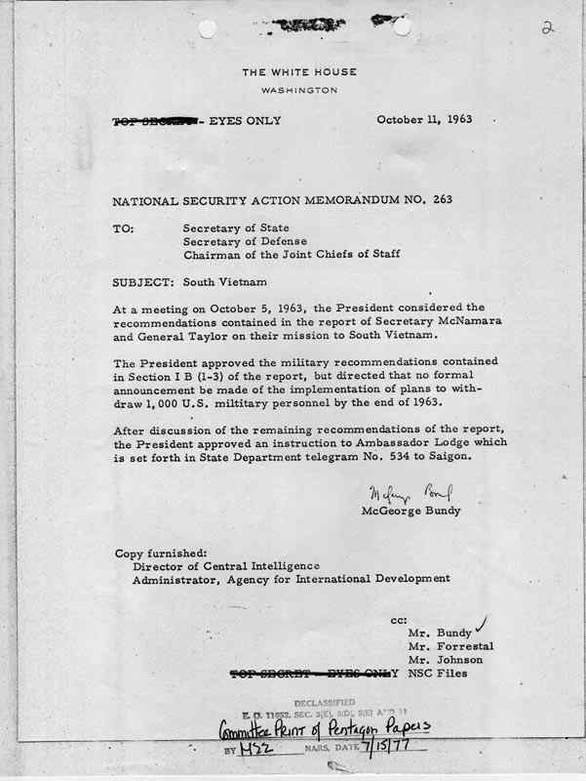
He was determined to pull the troops completely out after his re-election in 1964. Chomsky has argued that this is a morally pernicious decision, but in fact it’s just a matter of realpolitik; Kennedy knew that total withdrawal prior to 1964 would make him a one-term President. Since he obviously felt he could do more good than, say, Richard Nixon, it made sense for him to take this strategy. (3) Kennedy, following the Cuban Missile Crisis, was pursuing a policy of cooperation with the Soviet Union, as best shown by his fantastic American University speech. He wanted to have a joint Russo-American moon program.
In all three of these items JFK was bucking the establishment. And this doesn’t even get into his determination to destroy the CIA and “scatter it to the four winds,” as he said. To argue a structuralist viewpoint in light of these pertinent facts is to bury one’s head in the sand.
- Why Do You Still Care about this Case?
If forces within the government killed the President, then those involved parties need to be brought to justice. To not do so is to give up and to ensure that the democratic institutions which we allegedly have in this country will mean less and less over time. And it guarantees that we end up with laws like the Patriot Act and the Military Commissions Act, and that we will elect interchangeable leaders whose first love is to the donors who installed them into power. There is a direct line from the murder of President Kennedy to our own time, and this line has along it many way stations. These way stations include the murder of Bobby Kennedy, of Dr. King, the fake oil crises of the 1970s, the October Surprise, Reaganomics, the repeal of Glass-Steagall, and all of the idiotic invasions and wars, none having a viable explanation, that have passed since that time. No longer do we have a Marshall Plan, in which one could argue that there were good and bad points in our interference/assistance. At this moment, the primary export of the United States is death. And if we see hatred and fanaticism in response, we only have to look at our own history to see that we are accessories before the fact.
In Robert Bolt’s play A Man for All Seasons, Thomas More is imprisoned and threatened with death because he will consent to sign an Act drawn up by the King. He and Cromwell, his jailer, have the following exchange:
MORE: You threaten like a dockside bully.
CROMWELL: And how should I threaten?
MORE: Like a statesman, with justice.
CROMWELL: Oh, justice is what you’re threatened with.
MORE: Then I am not threatened.
More and Cromwell have very different ideas of what constitutes justice. For More, justice means universal justice, in which acts have consequences in a legal and fair manner; for Cromwell, justice is merely the advantage of the stronger, as Thrasymachus says in the Republic. So it is with us. If justice means something more than the exercise of power, then we must correct our own mistakes and reveal the scabs underneath. It is the first step toward repairing our prestige, and repairing ourselves.
- What is the Historical Context for the Kennedy Assassination?
Historical Background & Relevant People
This was the beginning of the period known as the Civil Rights Era. Several African American leaders became prominent in the social justice and peace movements; two of the most important were Martin Luther King and Malcolm X.
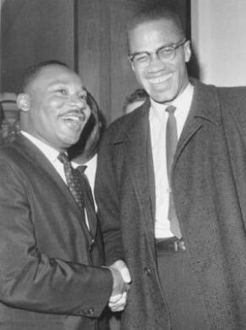
Dr. King and Malcolm X.
This was the time of the Cold War. Tensions between the United States and Russia (or, as it was known then, the Soviet Union) were at an all-time high.
Also in 1960, it is important to remember that Kennedy’s opponent was Richard Milhous Nixon. Nixon lost the presidency in an incredibly close vote in which the popular vote was with Nixon but the Electoral College put Kennedy in the White House. Whether true or not, Nixon had blamed the loss on the political machine in the state of Illinois, where the most powerful political figure was the mayor of Chicago, Richard Daley.
Kennedy’s running mate as Vice-President in 1960 was Lyndon Johnson. This was a political marriage, as Johnson was intended to help Kennedy in the South, especially to win all-important Texas. The two men did not especially like one another or agree with one another.
One thing that Kennedy used to draw a distinction between himself and Nixon was to come out and support Dr. Martin Luther King’s nonviolent resistance, going so far as to reach out to him when King was in jail for civil disobedience. Although JFK did not move quickly, or radically, in the direction of civil rights, this changed over his time in office, as did his views about a number of other things.
Rocking the Boat
Any summary this brief of the time period is inevitably going to be too simplified to be anything than other than an introduction to this material. However, even a cursory glance at what was going on during Kennedy’s presidency reveals a number of things:
- Kennedy grew to distrust his advisors, and actively ignored or even circumvented them.
- He fired three key people from the CIA, including the head, Allen Dulles, who was a legend dating back to World War II.
- He was withdrawing troops from Vietnam, when the official policy of the rest of the U.S. government was that Vietnam was a key piece of real estate in the Cold War against Communism.
- He was pursuing détente with Cuba and the Soviet Union.
- He had started to make overtures in the direction of civil rights.
- He signed a nuclear test ban treaty.
Furthermore, Kennedy was a popular president…with some groups.
Others felt that he was being soft on Communism by not sending in the air support, backing down from the Cuban Missile Crisis, have a détente with the Russians, and his new found interest in civil rights (which they saw as part of the communist conspiracy). It is in this type of thinking that the ideas of assassination begin to evolve.
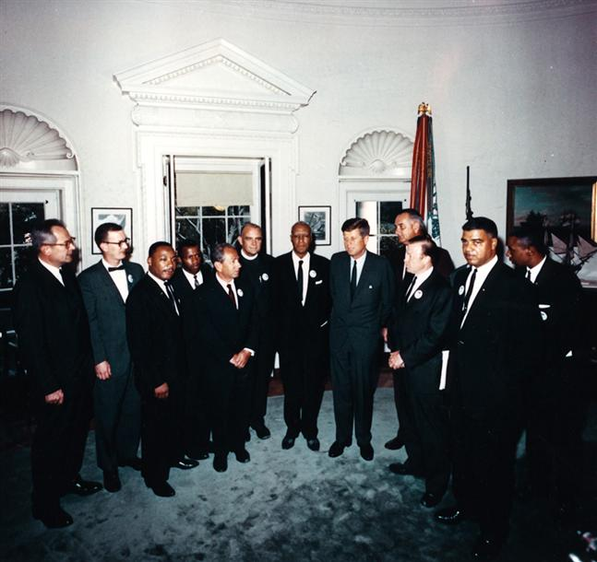
Kennedy meeting with Dr. King and other leaders during the march on Washington.
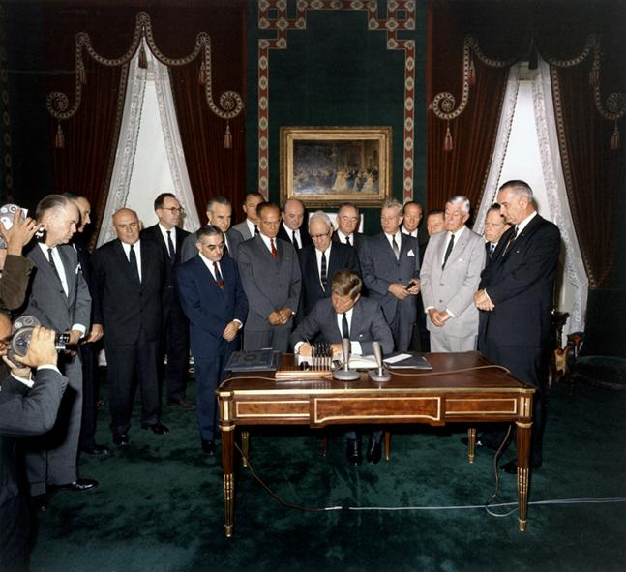
Kennedy signs the nuclear test ban treaty.
Closing Observations
John Kennedy was shot to death on November 22, 1963. The official government body to investigate the crime, the Warren Commission, concluded that it was the work of a lone nut by the name of Lee Harvey Oswald. In doing so, it ignored reams of evidence to the contrary, and more specifically evidence that pointed to an internal conspiracy.
The broader context of this assassination is that there were many other people on the left who were murdered in the year following the JFK murder – as if those who performed the deed were emboldened by their success.
Let’s look at two final sets of data. First, Richard Nixon.
Richard Nixon, during the 1960s and early 1970s, faced three major obstacles to being elected to the Presidency:
- JFK in 1960. As noted, Nixon lost the presidency under disputed circumstances.
- Bobby Kennedy in 1968. Bobby, of course, was himself assassinated right after the California primaries in 1968, which left no real challenger. Nixon was elected President for the first time in 1968.
- In 1972, with no serious opposition from the Democrats, a challenger did emerge from Nixon’s own party – a hard-right populist firebrand named George Wallace. Wallace was shot and paralyzed by Arthur Bremer in May of that year. Nixon won re-election in a landslide.
Please note: I am not making these observations to say that Nixon in any way had a hand in the assassination. In fact, Nixon himself appears to have been taken out during the Watergate scandal. However, it should be noted that whatever forces were working against the left leaders during this period, they benefited Richard Nixon. This says less about Nixon then about the inclinations of those who were trying to destroy the left during this time. Nixon was their guy, whether he knew it or not.
And now the last set of data:
- As noted, Robert Kennedy was murdered in June of 1968.
- MLK had been assassinated only two months earlier in Memphis.
- Malcolm X had been killed in 1965.
- Several members of the Black Panther party would end up dead in the following years, including Fred Hampton and Mark Clark, shot to death by police in December 1969. The rest of the leaders were either exiled or imprisoned, and the Party broke apart.
- Allard Lowenstein, who became a prominent Democratic leader (despite real reservations from his own party) after Bobby’s death, was much more moderate than other figures of this period. However, in 1980, he was also shot to death, in this case by his protégé, Dennis Sweeney.
- Harvey Milk, an activist who became the first gay man to hold a public office in California, was shot to death in 1978 by his colleague Dan White.
- John Lennon, who had been harassed by the FBI for many years and driven into semi-retirement, began to be more active in the late 1970s. Although a rock star, Lennon had always been an important counter-cultural figure and leftist icon. He was shot to death in 1980 in front of his hotel by Mark David Chapman. The hotel doorman, who witnessed the shooting, had been a member of the Cuban rebels and actually been present at the Bay of Pigs.
Were these deaths connected? A case can certainly be made for the first four. But even if each assassination were in isolation, one could hardly miss the pattern. Being an agent for change – real, democratic, change in favor of the people – is a dangerous business.
Bibliography and Sources for Further Research

BOOKS
Blight, James, and Janet M, Lang & David A. Welch. Vietnam If Kennedy Had Lived: Virtual JFK (Rowman & Littlefield Publishers, Inc.: NY 2009).
Bolden, Abraham. The Echo from Dealey Plaza (Harmony Books: NY 2008).
DiEugenio, James. Destiny Betrayed (Sheridan Square Press: NY 1992).
DiEugenio, James, and Lisa Pease, eds. The Assassinations (Feral House: Los Angeles 2003).
Douglass, Jim. JFK and the Unspeakable (Orbis Books: NY 2008).
Fetzer, James H., ed. Murder in Dealey Plaza (Catfeet Press: Illinois 2000).
Fonzi, Gaeton. The Last Investigation (The Mary Ferrell Foundation: 2008).
Garrison, Jim. On the Trail of the Assassins (Warner Books: NY 1988).
Groden, Robert. The Killing of a President (Studio Press: 1994).
Groden, Robert, and Cyril Wecht. The Search for Lee Harvey Oswald (Studio Press: 1995).
Groden, Robert, and Harrison Livingstone. High Treason (Conservatory Press: 1989).
Hancock, Larry. Someone Would Have Talked (JFK Lancer: Southlake, TX 2004).
Hepburn, James. Farewell America (Penmarin Books: CA 2002).
Higham, Charles. Trading with the Enemy (Barnes & Noble Books: NY 1983).
Kelin, John. Praise from a Future Generation (Wings Press: San Antonio, TX 2007).
Lane, Mark. Plausible Denial (Thunder’s Mouth Press: NY 1991).
Lane, Mark. Rush to Judgment (Thunder’s Mouth Press: NY 1992 [1966]).
Lifton, David. Best Evidence (MacMillan: NY 1980).
Lisagor, Nancy, & Frank Lipsius. A Law Unto Itself (William Morrow and Company: NY 1988).
Marrs, Jim. Crossfire (Carroll & Graf: NY 1989).
McKnight, Gerald. Breach of Trust (University Press of Kansas: 2005).
Meagher, Sylvia. Accessories After the Fact (Mary Ferrell Foundation Press: 2006 [1967]).
Mosley, Leonard. Dulles (Dial Press/James Wade: NY 1978).
Newman, John. JFK and Vietnam (Warner Books: NY 1992).
Newman, John. Oswald and the CIA (Skyhorse Publishing: NY 2008).
Prouty, L. Fletcher. JFK: The CIA, Vietnam, and the Plot to Assassinate John F. Kennedy (Citadel Press: NY 1992).
Prouty, L. Fletcher. The Secret Team (Skyhorse Publishing: NY 2008).
Pruessen, Ronald W. John Foster Dulles: The Road to Power (The Free Press: NY 1982).
Russell, Dick. The Man Who Knew Too Much (Carroll & Graf: NY 2003).
Scott, Peter Dale. Deep Politics and the Death of JFK (University of California Press 1993).
Stone, Oliver and Zachary Sklar. JFK: The Book of the Film (Applause Books: NY 1992).
Summers, Anthony. Conspiracy (Marlowe & Co: London 1994[1980]).
Talbot, David. Brothers (Free Press: New York 2007).
Thompson, Josiah. Six Seconds in Dallas (Random House: 1967).
Turner, William. Rearview Mirror (Penmarin Books: CA 2001).
Twyman, Noel. Bloody Treason (Laurel Publishing: E-Book Edition 2010).
Weberman, A.J. and Michael Canfield. Coup D’etat in America (Quick American Archives: 1992[1970]).
Weisberg, Harold. Whitewash (The Mary Ferrell Foundation: 2006 [1965]).

ARTICLES AND WEBSITES
Black Op Radio
www.blackopradio.com
DiEugenio, Jim. “Rose Cheramie: How She Predicted the JFK Assassination,” Probe Magazine, Vol. 6, No. 5, July-August 1999. http://www.ctka.net/pr799-rose.html
Lardner, Jr., George. “Staff Member Concludes 2 Different Specimens Were Examined,” The Washington Post, 10 November 1998; Page A03.
http://www.baylor.edu/lib/poage/jones/
The Penn Jones Collection at Baylor University. Penn was one of the first generation critics of the Kennedy assassination and is a fascinating character in his own right.
www.ctka.net
Citizens for Truth about the Kennedy Assassination, site of the former Probe Magazine.
http://jfk.hood.edu/index.shtml?browse.php
The Harold Weisberg Archive online.
www.jfkmi.org
http://www.facebook.com/pages/JFKMI-Inc/146613894244
JFKMI Organizational websites.
www.judgeforyourself.us
http://www.ratical.org/ratville/JFK/JohnJudge/ATF.html
John Judge’s website, containing links to articles compiled over almost a half-century of research. Also a specific interview entitled “Assassination as a Tool of Fascism” which was quite helpful in putting together this document.
www.maryferrell.org
The Mary Ferrell Foundation – an invaluable documentary resource site.
www.patspeer.com
Pat Speer’s website, focusing on the medical evidence.
www.politicalassassinations.com
The website for the Coalition on Political Assassinations.

